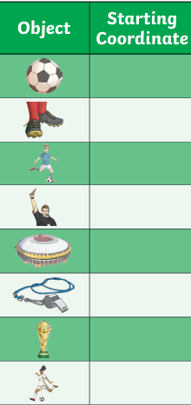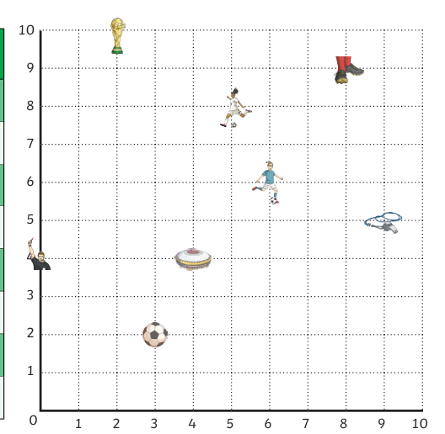

Now design your own co-ordinate game for a friend/classmate to complete. You can add in extra football items (scarf, pitch, water bottle, shirt, flag etc) You could make it themed to a specific country.

