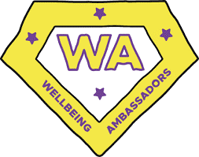
Heatherside Junior’s Wellbeing Summer Outdoor Challenge

The Wellbeing Ambassadors would like to set you a challenge for the summer holidays…
This year, we would like you to complete 5 activities linked to the 5 Ways to Wellbeing.
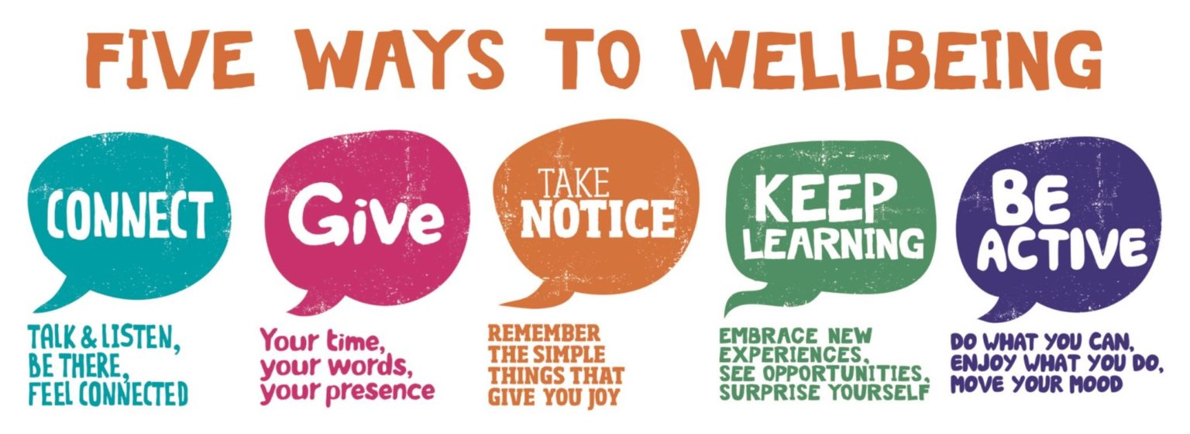

All you need to do is take photos of you doing your activities and bring them into your new class teacher in September, to share your adventures! Your name will then be entered into a prize draw, and the winner will be announced in assembly. Everyone will be awarded a house point for completing a task.
The Wellbeing Ambassadors have come up with a long list of ideas below for each of the 5 ways, all of which will benefit your physical and mental health. However, feel free to come up with your own ideas! Always make sure you have an adult’s permission for the activities.
Remember to put your full name on the photos and your September class if you want to be in with a chance of winning!
Connect  - Play team games/complete team challenges with your family or friends  - Have a go at inclusive sports  - Make a den together  - Read to someone else  - Build a bug house with a friend  - Have a screen-free day  - Have a kitchen disco  - Have a games evening with your family  - Read a book recommended by a friend and share the best bits. | Give  - Donate to a charity  - Swap paintings  - Meditate  - Go on a litter pick (safely!)  - Plant some wildflowers  - Help clean something  - Make a sweet treat and share with friends/neighbours

Take Notice  - Find a free local sensory trail  - Identify trees/plants/bugs whilst on a walk  - Cloud spot  - Go for a slow walk in a new place  - Sit silently in nature for 5 minutes – what do you notice?  - Help with the gardening/watering | Keep Learning  - Try a new educational game  - Practise your times tables  - Find out the most interesting facts about any new places you visit  - Visit the theatre (indoor or outdoors)  - Practise playing an instrument  - Learn 3 new words in a foreign language or practise on holiday  - Play a new board game
Be Active
- Go for a run, scoot or walk
- Play stuck in the mud
- Get your friends together to play rounders or cricket
- Set up some relay races
- Shoot some hoops
- Have a kick around
- Go on a bike ride
- Build a sandcastle



