My Online Safety Rules
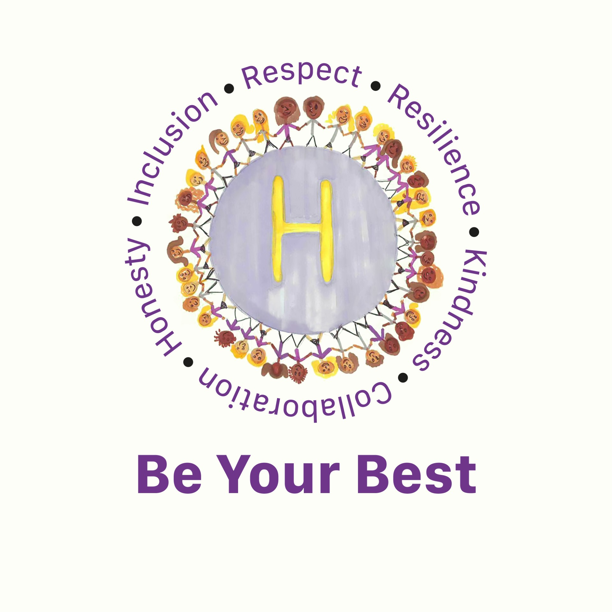
Being Safe
- I will follow the school rules: I will use school devices and the internet only when I am allowed and for schoolwork.
- I keep passwords safe: I will never share my passwords and will tell a teacher if someone else finds them out.
- I check before I click: I will not click on strange links that I do not know, or pop-ups without checking with a teacher, or parent/carer, nor download things without permission.
- I only use AI tools when there is a trusted adult has given me permission: I will not use names or upload personal images or photos of people I know to AI platforms.
- I respect age limits: I will not use 13+ games or apps, as they are not safe for me.
- I protect my identity: I will not share private details like my address or phone number.
- I can say no online if I need to: I don’t have to do something just because someone dares or challenges me to do it, or to keep a secret. If I get asked anything that makes me worried, upset or just confused, I will say no, stop chatting and tell a trusted adult immediately.
- I am a safe researcher: I use safe search tools approved by my trusted adults. I know I can’t believe everything I see, and I know which sites to trust, and how to double check information I come across.
- I don’t livestream on my own: I check with a trusted adult before I video chat with anybody for the first time.
Being Kind
- I am a good friend and ally: I will not post or share unkind, rude, or hurtful messages, images, or videos. If a friend is worried or needs help, I remind them to talk to an adult or I can help them report it to a trusted adult.
- I know what 'banter' means: I know that calling someone names is not 'fun' or 'banter'—it can hurt people.
- I don't take secret photos or videos: I will not take pictures or videos of others without their permission. I will never create fake images, videos, or 'deepfakes' of anyone.
- I respect work: I only use other people's work (pictures or words) if I have permission.
Using Technology Responsibly
- I check with an adult: I am careful when someone wants to be my friend. Unless I have met them face to face, I can’t be sure who they are. I will talk to a trusted adult before chatting with anyone new, even if they claim to be a friend or are a 'chatbot'.
- I know my body is mine: I will not send photos or videos of myself or get changed in front of a camera. If I feel uncomfortable, I will stop and tell a trusted adult.
- I don't pretend to be someone else: I am always honest about who I am online.
- I am careful what I share and protect my online reputation: I know anything I do can be shared and might stay online forever (even on Snapchat or if I delete it).
What to do if something goes wrong
- It’s not my fault: If I see something bad online or receive an unkind message, it is not my fault. I will not get in trouble for telling an adult.
- I tell someone: If I see or experience something that makes me feel worried, upset, or confused, I will stop what I am doing and tell a trusted adult straight away.
My Trusted Adults
At school, my trusted adult/s is/are: _______________________________________
At home, my trusted adult/s is/are: _______________________________________
My name _______________________________________________ Date ________________

