
‘working with parents to ensure the best possible outcomes for children’
Fleet Area Parent Support Advisor

Parenting
The
Anxious Child



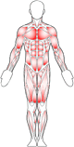
Some physical signs of anxiety:

This is just a small list of possible physical signs:-
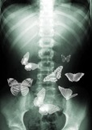
- Increased heart rate
- Rapid breathing
- Sweaty palms
- Light-headedness, feeling dizzy or faint
- Stomach ache/tightening

- Needing the toilet
- Crying
- Wobbly knees

Remember:

When we become frightened or worried our bodies go through many changes and this is a normal response. If our body perceives a threat it gets us ready to react to it by releasing a flood of hormones including adrenaline and cortisol. These hormones trigger physical changes to ‘get us ready’ to either fight or flee from the danger.

A little bit of worry helps us…e.g. the worry of feeling hungry helps me remember my lunch, the concern over getting a detention helps me to remember to take my homework in, my nerves before an exam helps my brain to retrieve all the facts that I’ve worked hard to learn.

It’s about managing our worries and not letting them stop us from doing things!

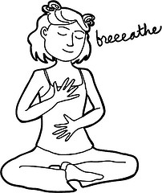
Controlled Breathing

When we control our breathing the brain sends signals to the body to stop releasing the adrenalin and that helps us to become calm:-

- Place one hand on your chest
- Place one hand on your stomach (tummy)
- Breath in – only your stomach (tummy) can move – if your chest is moving you need to take a deeper breath in
- Once you have the breathing right do it ten times – calm and controlled.
Thoughts and Feelings Affect Behaviour

Thoughts
Feelings
Behaviour

We sometimes try to avoid situations or problems to tackle anxiety…and then end up encouraging our children to do the same instead of helping them to manage their anxiety.

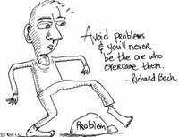
The Worry Scale

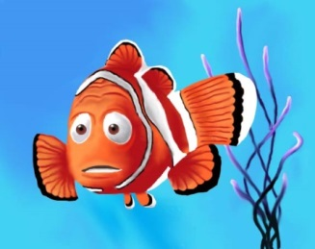
- 10 - Extremely worried
- 9
- 8 - Very worried
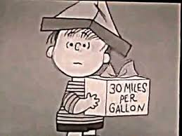
- 7
- 6 - Worried
- 5
- 4 - A bit worried
- 3

- 2 - Not sure
- 1
- 0 – Very relaxed
Evidence for my Own Story

This is by no means an easy skill to learn, for adults or children. Before you move on to teaching your child about the skill try it for yourself.

- Think of a recent event that caused you worry?
- What was your thought or belief about this event?
- How worried were you? (Use the worry scale)
- What has happened with a similar worry in the past?
- What information is available about this event?
- What alternative explanations are there?
- If you were in another’s shoes, what would you believe?
- How bad would it be if what you believe did come to pass?
- Given all of this evidence what would have been a realistic belief to hold?
- If you had held this belief instead, how worried do you think you would have been? (Use the worry scale)

Remember to use ‘child speak’

Detective Thinking

Event  What is happening? | I am being taught a new skill during PE
Thoughts  What am I thinking? | I look like an idiot; I can’t do it  Worry rating: 10
What is the evidence? | Everyone is learning, and only some seem to be able to do it.  The idea is to practice till I get it right.  I can usually do new skills ok; I don’t need to be perfect at it.
What is my realistic thought? | Just give it a try; that’s the only way to learn.  Worry rating: 5

Event  What is happening? | I just closed the front door.
Thoughts  What am I thinking? | My hands are dirty; if I don’t wash them I will get sick.  Worry rating: 9
What is the evidence? | There is nothing visible on my hands.  I have closed a lot of doors in my life and I haven’t got sick.  My body has the antibodies to cope with germs.  A lot of very rare things would all have to happen in a row for me to actually get sick.  A lot of people don’t even bother to wash at all and they don’t get sick.
What is my realistic thought? | My body can cope with a few germs if there were any there to catch.  Worry rating: 5

Detective Thinking

Event
What is happening?
Thoughts
What am I thinking?
What is the evidence?

What is my realistic thought?

Event
What is happening?
Thoughts
What am I thinking?
What is the evidence?

What is my realistic thought?

Unhelpful ways to deal with anxiety:

- Excessive reassuring your child
- Being too involved and directive
- Permitting avoidance
- Becoming impatient
- Dismissing the emotion

Helpful ways to deal with anxiety:

- Rewarding brave non anxious behaviour
- Ignoring behaviours you don’t want
- Prompting your child to cope constructively
- Modelling brave non anxious behaviour

Important principles to remember:

- Be consistent
- Keep your own emotions in check
- Distinguish between misbehaviour and anxious behaviour
- Reward positive/brave behaviour
- Manage misbehaviour behaviour
- Removal of privileges
- Natural/appropriate consequences.

What am I going to change?

What parenting trap am I currently falling into? | What will I do differently?
How successful was I?

Do you respond positively or negatively?
What is it that my child did? | What action did I take (praise or punishment) | What happened when I did this (what was my child’s response)
Notes

