Cheesecake with Fresh fruits

Ingredients
- 100 g digestive biscuits, or cookies, crushed into fine crumbs
- 50 g butter, melted
- 500 g half-fat cream cheese
- 100 g icing sugar
- 1 tsp vanilla extract
- 200 ml double cream, lightly whipped .

Method
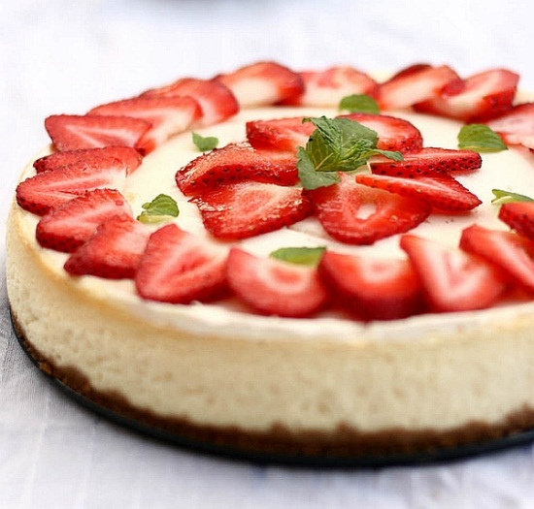
1. Crush the digestives with a rolling pin. In a mixing bowl, mix together the biscuit crumbs and melted butter. Mix well.
2. Spoon the biscuit mixture into individual ramekin dishes.. Use a metal spoon to press the biscuit crumbs down firmly and evenly. Chill in the refrigerator or freezer to set.
3. In a large mixing bowl, using a whisk or a wooden spoon, beat together the cream cheese, icing sugar and vanilla extract until well mixed.
4. Fold in the double cream, mixing well.
5. Spoon the cream mixture over the chilled biscuit bases, making sure that there are no air bubbles. Smooth the top of the cheesecake with a palette knife or metal spoon.
6. Chill the cheesecake in the refrigerator for as long as you have! To serve, decorate with fresh fruit.

